GAS PROCESSING & METHANOL COMPLEX PROJECT NO. 11998A

Project | FEED for Gas Gathering Pipelines & Associated Infrastructure
Client | Brass Fertilizer and Petrochemical Company Limited
Originating Company | Epic Atlantic Limited
Document Title | Slug Catcher Preliminary Specification
Document Number | EA-BFPCL-GPMC-GGPL-FEED-PSE-SPC-001
Document Revision | R00
Document Status | Issued For IDC
Originator | Ridwan Olagoke
Security Classification | Restricted
Issue Date | 05 Jun 2022

Slug Catcher Preliminary Specification
R00 | 05 Jun 2022 | Issued for IDC | Olagoke Ridwan | Kazeem Yusuff | Aloy Duru
Rev # | Issue Date | Status  Description | Originator | Reviewer | Approver  (Epic) | Approver  (BFPCL)

 | 

Revision History
Rev. No. | Date | Description of Revision

Review Code & Status (to be filled by Client)
☐ Code 1 | Final – Do not resubmit unless modified.
☐ Code 2 | Revise & Resubmit – Incorporate Comments. Up-Rev & Resubmit. Work May Proceed
☐ Code 3 | Review Not Required – Do not Resubmit.
☐ Code 4 | Rejected – Incorporate Comments. Up-Rev & Resubmit. Work May Not Proceed
Date: | Position: | Sign:

Revision Philosophy:
- All documents for review shall be issued at R01, with subsequent R02, R03, etc as required.
- All documents approved for issue or approved for design shall be issued at A01 with subsequent A02, A03, etc. as required. (Management of Change is required for A02, A03, etc.)
for the subsequent project phases, post FEED, it is expected that:
- All Detailed Design documents for review shall be issued at D01, with subsequent D02, D03, etc. as required.
- All documents approved for construction shall be issued at C01 with subsequent C02, C03, etc. as required. (Management of Change is required for C02, C03, etc.)
- All approved “As-Built” documents shall be issued at Z01, with subsequent Z02, Z03, etc as required. (Use versions Z01.1, Z01.2, Z01.3, etc to review the “As-Built” document to Z02).

Restricted
This document is made available subject to the condition that the recipient will neither use nor disclose the contents except as agreed in writing with the copyright owner. Copyright is vested in Brass Fertilizer and Petrochemical Company Limited (BFPCL) © All rights reserved.
Neither the whole nor any part of this document may be reproduced or distributed in any form or by any means (electronic, mechanical, reprographic, recording, or otherwise) without the prior written consent of the copyright owner.

SUMMARY PAGE
Client: | Brass Fertilizer & Petrochemical Company Limited
Project: | Gas Processing & Methanol Complex | Project No. 11998A
Facility: | Gas Gathering Pipelines & Associated Infrastructure | Doc No.  EA-BFPCL-GPMC-GGPL-FEED-PSE-SPC-001-R00

The administration of this document is in respect of FEED for Gas Gathering Pipelines & Associated Infrastructure for the Gas Processing & Methanol Plant Project of BFPCL.
The Pipelines will be implemented in two phases, - starting with BBOU & ELEP as Phase 1and followed by NUNR, SEIB & OPUG as Phase 2. The focus of the present FEED is on Phase 1, while Phase 2 will be implemented later.
The document, in consideration of relational design elements & concepts, forms the technical basis for the development of the facilities Project Specifications & tendering of contracts for the project’s implementation.
It is also a precursor and accompaniment to the FEED study & report that will lead to the project’s FID and implementation.
The report has relied on and used data and reference documents provided by the client, and if further documents and information become available, Epic Atlantic reserves the right to update the opinion set out in this report.
For better appreciation, this document should be read in conjunction with the references listed below, which are the Concept Select Study reports that constitute basis for the Conceptual Study.
KEYWORDS: BASIS OF DESIGN, PIPELINE, MANIFOLD, PLATFORM, MULTIPHASE FLOW, ROW, PTS

REferences
Document No. | Description
EA-BFPCL-GPMG-GGPL-FEED-PSE-RPT-001 | Upstream Gas Gathering Concept Select & Revalidation Report

Table of Contents
Project Information, Terms, Abbreviations, and Definitions 7
Project Information – General 7
Project Information – General (Contd) 8
Definition of Terms 9
Abbreviations 9
Abbreviations (contd.) 10
Abbreviations (contd.) 11
1. Introduction 12
1.1. Background Information 12
1.2. Purpose of Document 15
1.2.1. The Phase 1 Facilities 15
1.2.2. The Phase 2 Facilities 15
1.3. The Phase 1 Pipelines Route / Right of Way 15
1.4. Scope 15
1.5. Design Battery limits 16
1.5.1. BBOU Platform 16
1.5.2. ELEP Platform 16
1.5.3. Akabel Facility 16
2. Regulations, Codes And Standards 17
2.1. Regulations 17
2.2. References 17
3. Slug Catcher Preliminary Specification 19
3.1. Type Selection 19
3.2. Slug Volume & Slug Catcher Calculations 21
3.2.1. Liquid Hold-up Calculations 21
3.2.2. Calculations Notes 22
3.2.3. Slug Catcher Calculations Summary Results 28
3.3. Slug Catcher Summary 30
3.4. The Slug Catcher Sketch 31
4. MECHANICAL DESIGN 34
4.1. GENERAL 34
4.2. MAXIMUM ALLOWABLE OPERATING PRESSURE 34
4.3. DESIGN FACTOR FOR HOOP STRESS 34
4.4. OTHER STRESS 34
4.5. SUPPORTS AND ANCHORS 35
4.6. MATERIAL SELECTION 35
4.6.1. Linepipe 35
4.6.2. Fittings 35
4.6.3. Flanges 35
4.6.4. Valves 35
4.6.5. Prevention of brittle fracture 35
4.7. WELDING 36
4.8. INTERNAL/EXTERNAL CORROSION PROTECTION 36
4.9. OVERPRESSURE PROTECTION 36
4.10. MAINTENANCE 36

Project Information, Terms, Abbreviations, and Definitions

Project Information – General
1.0 | Employer | BRASS FERTILIZER & PETROCHEMICAL  COMPANY LIMITED (BFPCL)
2.0 | PMC | TATA CONSULTING ENGINEERS LIMITED (TCE)
3.0 | EPCC (CONTRACTOR) | CHINA TIANCHEN ENGINEERING  CORPORATION (TCC)
4.0 | Project Title | Gas Processing and Methanol Complex
5.0 | Location | Akabel, Brass Island.  The project site is about 85km South West of Port Harcourt, 70km South of Yenagoa and 90km West of Bonny Island.
5.1 | State | Bayelsa State, Nigeria
5.2 | Nearest Air Port and distance | Port Harcourt Airport (PHC)  Bayelsa Airport (Under Construction)
5.3 | Nearest Port | Port Harcourt (Onne)
5.4 | Nearest Railway Station &  distance | -
5.5 | Highway and distance | Connected through water way only. Road  connection does not exist.
5.6 | Important Town and distance | Yenagoa, Nigeria& 67 km
5.7 | Altitude Above Mean Sea Level | 9 m
5.8 | Atmospheric pressure
 | Average | 1013 mbar
6.0 | Ambient Air Temperatures | (Refer Note-5,6)
6.1 | Maximum | 38°C
6.2 | Minimum | 18°C
6.3 | Average | 23°C
6.4 | Summer Design Wet Bulb Temp | 28°C
6.5 | Winter Design Wet Bulb Temp | 15°C
6.6 | MDMT | 15°C
6.7 | Swamp temperature | 250C. (230C. to be used wherever a margin is  required)
6.8 | Ground temperature | 25 - 27.50C.
6.9 | Black-bulb temperature: | 800C.
7.0 | Relative Humidity
7.1 | Maximum | 95 %
7.2 | Minimum | 51 %
7.3 | Average | 73 %
8.0 | Rainfall Data
8.1 | Average annual rainfall | 3800mm
8.2 | Max daily rainfall: | 180mm
8.3 | Mean max. Hourly rainfall | 100mm
9.0 | Transport
9.1 | Name of the highway near which  the plant is located | Connected through water way only. Road  connection does not exist.
9.2 | Access road | -
9.3 | Railway (Gauge) | -
10.0 | Wind Data
10.1 | Design Wind Velocity | 35.6 m/sec (Note-1)
10.2 | Wind Direction | Note-2
11.0 | Seismic Data
11.1 | Earthquake Zone | Note-3
12.0 | High Flood Level (HFL) | *
13.0 | Natural Ground Level | *
14.0 | Slope | *
15.0 | Drainage | *
16.0 | Design temperature for Electrical equipment | 400C

Project Information – General (Contd)

Definition of Terms
TERMS | DEFINITIONS
BFPCL | Brass Fertilizer & Petrochemical Limited.
SPDC | Shell Petroleum Development Company Nig. Limited
Employer | Party (Usually BFPCL) that initiates the project and ultimately pays for its design and construction. The Employer will generally specify the technical requirements. The Employer may also include an agent or consultant authorized to act for and on behalf of, the Employer.
Engineer | The party that carries out the FEED Engineering of the project.
Manufacturer/Supplier | Party, which manufactures or supplies equipment and services to perform the duties specified by the Contractor.
Shall | The word ‘shall’ indicate a mandatory requirement.
Should | The word ‘should’ indicate a recommendation.
Measuring Range | Range defined by LRL and URL within which the limits of uncertainty of the measuring instrument are specified (the capability of the instrument).
On-Line Instruments | Instruments connected to process and utility lines or equipment via primary isolation valves.
Project | Front End Engineering Design for Gas Gathering Pipelines (Phase1)

Abbreviations
ABBREVIATION | MEANING
AASHTO | American Association of state Highway Transportation Officials
AGEF | Above Ground End Facilities
ALARP | As Low as Reasonably Practicable
API | American Petroleum Institute
ASTM | American Society of Testing and Materials
BOD | Basis Of Design
CP | Cathodic Protection
CPT | Cone Penetrometer Test
CTMS | Custody Transfer Metering Station
DB&B | Double Block and Bleed
DCQ | Daily Contractual Quantity

Abbreviations (contd.)
ABBREVIATION | MEANING
DEP | Design and Engineering Practice
ESD | Emergency Shutdown
ESDV | Emergency Shutdown Valve
FEED | Front End Engineering Design
FGS | Fire, Gas and Smoke detection systems
GPP | Gas Processing Plant
GTG | Gas Turbine Generators
HAZID | Hazard Identification
HAZOP | Hazard Operability
HEMP | Hazards and Effects Management Process
HFE | Human Factors Engineering
HPU | Hydraulic Power Unit
HRA | Health Risk Assessment
HSES | Health, Safety, Environment and Security
HSSE & SP | Health, Safety, Security, Environment and Social Performance
IEC | International Electro-technical Commission
ISPM | Industry Standard Process Modules
JV | Joint-Venture
LCD | Liquid Crystal Display
LOI | Local Operator Interface
LRL | Lower Range Limit
LRV | Lower Range Value
LIRA | Logistics and Infrastructure Resource Assessment
MAC | Main Automation Contractor
NAG | Non-Associated Gas
OPC | OLE for Process Control
OPPS | Overpressure Protection System

Abbreviations (contd.)
ABBREVIATION | MEANING
PCD | Process Control Domain
PDMS | Plant Design and Management System
PEPF | Package Engineering, Procurement, and Fabrication
PIG | Pipeline Inspection Gauge
PVC | Polyvinyl Chloride
RTR | Reliability Test Run
SCE | Safety critical elements
SI | International System Units
SIL | Safety Integrity Level
SRB | Sulphate Reducing Bacteria
SIS | Safety Instrumented System
SWB | Steel Wire Braiding
URV | Upper Range Value
USC | US Customary Units
XLPE | Cross Linked Polyethylene
TEG | Tri-ethylene Glycol
TQ | Top Quartile

Introduction

Background Information
Brass Fertilizer and Petrochemical Company Limited (BFPCL) is developing a greenfield methanol production facility in Akabel (Odioma), Brass LGA Bayelsa state. The plant complex is to be based on natural gas feedstock from 5 SPDC fields, namely: Bubouwe Bou & Elepa, in OML 33, Nun River, Seibou, in OML 35, and Opugbene in OML 36.
The Project involves the development, construction, and operation of a 10,000 metric tonnes per day (MTPD) capacity methanol production plant comprising the following elements:
- Two trains of 5,000 MTPD methanol plant, producing a total of 10,000 MTPD of methanol
- 340 MMscfd Gas Processing Plant (“GPP”), which will extract NGL from the natural gas feedstock, prior to feeding the lean gas to the methanol plant.
- Gas gathering pipelines and associated manifolds transporting the natural gas from five fields, viz: Bubouwe Bou (BBOU), Elepa (ELEP), Nun River (NUNR), Seibou (SEIB), and Opugbene (OPUG) to the GPP at Akabel, - as shown in Figures 1.1, 1.2, & 1.3.
- Product Export Lines and associated Offshore Single Buoy Mooring (SBM) for the export of the methanol, and NGL of the GPP.
- All offsite, utility, and off-plot facilities (including product storage, internal power generation, steam generation, and export jetty) which are required for the operation of the processing plants.
Tata Consulting Engineers Limited (TCE) is the Project Management Consultant for the project.
The Nodal Gas Gathering Schematics
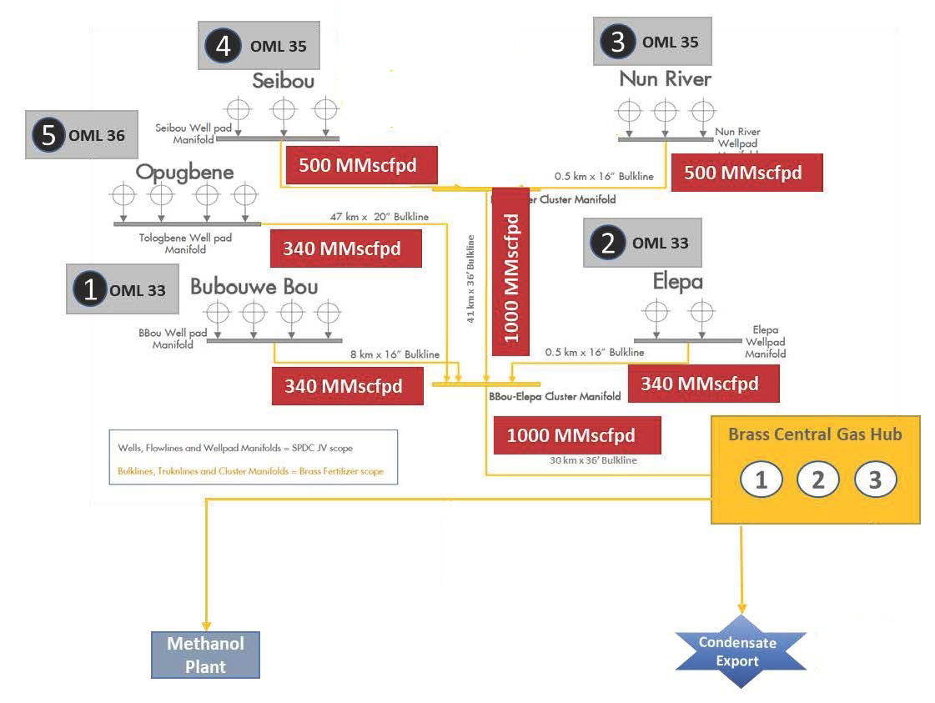 | Gas Gathering from five SPDC Nodes
Figure 1-1: Field & Nodes covered in the Gas Gathering

The Nodal Gas Gathering Schematics (contd.)
Figure 1-2: Gas Gathering Concept, Phase 1
Figure 1-3: Wholistic Gas Gathering Concept, Phase 1 & 2

Purpose of Document
The purpose of this document is to provide the preliminary design, selection criteria and specification for the slug catcher for the development of the Gas gathering Project.
The gas gathering will be in two phases, as shown in the schematics below:
- Phase 1 comprising gas gathering from Bubouwe Bou and Elepa fields, and
- Phase 2 comprising gathering from Nun River, Seibou, and Opugbene fields.

The Phase 1 Facilities
The phase 1 facilities (shown in Figure 1.1) are:
- BBOU – ELEP pipeline
- ELEP - AKAB Pipeline
- BBOU satellite Manifold
- ELEP evacuation Manifold, and
- The Pipeline End Manifold at AKAB.
These phase 1 facilities are the focus of the present FEED, however with consideration for provisions and retrofits that will accommodate the phase 2 facilities in a rather seamless manner.
The pipeline route proposed for this phase 1 has been surveyed, and the survey report issued for the FEED. The phase 2 pipelines routes are yet to be defined and surveyed.

The Phase 2 Facilities
The phase 2 facilities comprise NUNR, SEIB, and OPUG Manifolds with their pipelines connecting to phase 1 facilities as shown in Figure 1.2.

The Phase 1 Pipelines Route / Right of Way
The pipeline route / Right of Way, running from BBOU through ELEP to AKAB is shown in the satellite image below
Figure 1-3: Satellite Image of the proposed BBOU – ELEP-AKAB Right of Way

Scope
The Facilities to be covered under project scope are:
- Satellite Manifold at BBOU complete with all Process, Utility & Control Infrastructure, however with provision for future installation of PIG receiver as will be required for phase 2 production from OPUG.
- Evacuation Manifold at ELEP complete with all Process, Utility & Control Infrastructure, however with provision for future installation of PIG receiver as will be required for phase 2 production from NUNR.
- Pipeline from BBOU to ELEP
- Pipeline from ELEP to AKAB (up to Inlet Flange of Slug Catcher)
- PIG Launchers at BBOU and ELEP Manifold
- PIG Receivers at ELEP and AKAB
- Manifold control system also to be provided. Control Room required at each Manifold to house the Manifold Control system & Telecom system
- Cabinet Room to house the electrical MCC.
- UPS Power for Control System, associated Civil, Mechanical, Pipeline, Electrical, Instrumentation & Control, Telecommunication, and all other supporting infrastructure.
The Scope of the FEED Engineering covers the provision of all necessary information, technical drawings, philosophies, specifications, design data, listing of codes and standards required for the detailed design and construction of the Multiphase pipeline system.

Design Battery limits
The battery limits for this Phase 1 FEED Project are:

BBOU Platform
- The terminal flanged ball valve on the manifold collecting well fluids from BBOU Wells.
- The flanged ball valve provided for the tie-in of Opugbene (OPUG) Pipeline on the manifold transporting well fluids to ELEP.

ELEP Platform
- The terminal flanged ball valve on the manifold collecting well fluids from ELEPA Wells.
- The flanged ball valve provided for the tie-in of NUN River Pipeline on the manifold transporting well fluids to AKAB.

Akabel Facility
- The Pipeline terminal flange at the inlet to the slug catcher at AKAB.
- The drain outlet flange on the pig receiver at AKAB.

Regulations, Codes And Standards

Regulations
The following listed regulations in the below table will be used in the project as applicable.
Regulation | Function
Petroleum Act, CAP P10, Laws of the Federation of Nigeria, LFN 2004, amended. | This is BFPCL statute regulating the oil industry.  The following regulation relevant to this project is issued pursuant to the Act.
Mineral Oil (Safety) Regulations 1963, as amended. | These regulations, in so far as they apply to pipelines, require compliance with relevant IP, API and ASME codes and standards.
Oil Pipelines Act, 1956. CAP. 145 (Amended 1965, CAP. 338, LFN 1990) | Provides for licenses to be granted for the establishment and maintenance of pipelines incidental and supplementary to oilfields and oil mining, and for purposes ancillary to such pipelines.
Oil and Gas Pipelines Regulations, 1995 | Details the regulations for the design, construction and maintenance of oil and gas pipelines.
Environmental Impact Assessment Act, CAP E12, LFN 2004. | Makes the conduct of an EIA mandatory prior to the development of any project or activity likely to have a significant effect on the environment
Federal Environment Protection Agency Act, CAP F13, LFN 2004. | Provides for the protection of the environment and sustainable development of Nigeria’s natural re- sources.
Environmental Guidelines and Standards For The Petroleum Indus try In Nigeria, 1991. | DPR (NUPRC) issued document providing guidelines on pollution abatement and relevant legislation.

References
The following listed reference documents in the below table will be used in the project as applicable.
Document Number | Title
EA/SPDC-BFPC UGS-GEP/CSM-RPT-002 | Gas Gathering & Evacuation Pipelines Concept Screening
EA/SPDC-BFPC UGS-GEP/CSM-RPT-001 | Conceptual Study Memorandum
EA/SPDC-BFPC UGS-GEP/SVY-RPT-001 | Pipeline Route Selection Study
EA/SPDC-BFPC UGS-GEP/PRC-RPT-001- 3 | Process Simulation Study – HYSYS, PIPESIM, & OLGA
EA/SPDC-BFPC UGS-GEP/MAT-RPT-001 | Pipeline Materials Selection & Corrosion Analysis Study
EA/SPDC-BFPC UGS-GEP/ELE-RPT-001 | Manifold Platforms Power Supply Options
EA/SPDC-BFPC UGS-GEP/MEC-RPT-001 | Manifold Platforms Concept & Integration with SPDC
EA/SPDC-BFPC UGS-GEP/PRC-RPT-002 | Gas Processing Technology Option
6064/PLRS/001a-PRP | Onshore Pipeline Route Survey for BFCL; Topographical  Surveys
6064/PLRS/001PRP | Onshore Pipeline Route Survey for BFCL; Soil Investigation Surveys
40km Gas Supply Pipeline Project ESIA | Environmental and Social Impact Assessment Report prepared by Messrs. Fundamental Integrated Site Appraisal Services Limited - Draft Report November 2020.
DEP 31.40.40.38-Gen. | Hydrostatic pressure testing of new pipelines
DEP 33.64.10.ok g10-Gen. | Electrical engineering guidelines
DEP 61.40.20.30-Gen | Welding of pipelines and related facilities
The latest versions of the regulations, codes, and standards and extant amendments or supplements shall apply. Local laws regulating the oil and gas industry in Nigeria shall be strictly adhered to. The order of precedence for the documents shall be as follows:
- Nigerian Local Standards and Codes
- The Contract
- Project Specifications
- Employer’s Standards
- Shell DEPs
- International Codes and Standards
In all cases, the most stringent shall apply except where constraints dictate otherwise.
Conflicts between specifications and referenced Codes and Standards or deviations thereof shall be referred in a Technical Query (TQ) to the EMPLOYER for resolution.

Slug Catcher Preliminary Specification

Type Selection
Pipe-Finger Slug Catcher is selected as most suitable type, following Type Selection Decision Tree developed by BP, and widely used in the Oil & Gas Industry. The red line in the tree shows the flow of decision leading to the selection of the finger type slug catcher for this Project.
Figure 5.1: Slug Catcher Type-Selection Decision Tree

Slug Volume & Slug Catcher Calculations
The calculation for the slug volume and slug catcher was based on the maximum flow of gas at a pressure of 100 barg. Slug generated from BBOU-Elepa and Elepa-Akabel pipelines were cumulated to form the expected slug volume. A margin of error of 20% was added to account for process upsets and other unforeseen incidents that could increase the slug volume.

Liquid Hold-up Calculations

 | LIQUID HOLDUP VOLUME CALCULATION
 |  |  | 100 barg Pressure
 | Parameters |  | BBOU-ELEP Pipeline | ELEP-AKAB Pipeline | Units
 | Pipeline Outside Diameter |  | 610 | 914 | mm
 |  |  | 578.24 | 866.34
 | Pipeline Internal Diameter |  | 0.57824 | 0.86634 | m
 | Pipeline Area |  | 0.263 | 0.589476661 | m2
 | Mean Liquid Hold Up |  | 0.1644 | 0.261280054
 | Pipeline Length |  | 6662.74 | 35676.75 | m
 | Liquid holdup Volume |  | 287.5960 | 5494.879293 | m3
 | Expected Liquid Hold Up Volume |  |  | 5782.4753 | m3
 | Parameters |  |  | 2027 - 340MMSCFD | Units
 |  | Expected Slug Volume (20% margin) |  | 245047.427 | ft3

Calculations Notes

Fluid Properties

Properties From Simulation Program
The following properties of the fluid were determined from the HYSYS Simulation for maximum gas flow of 340MMSCFD..

Table 1: Fluid Properties from HYSYS SimulationError! Not a valid link.Derived Properties
Using information from Table 1, following relevant properties of the fluid needed for the slug catcher sizing were derived using formula stated.
      - Total Liquid Mass Flow Rate: W_{L} = W_{C} + W_{W}
      - Density of Liquid: $\frac{W_{L}}{\frac{W_{C}}{ρ_{C}}+\frac{W_{W}}{ρ_{W}}}$
      - Volumetric Flow Rate of Gas: $\frac{W_{g}}{{3600×ρ}_{g}}$

      - Volumetric Flow Rate of Liquid:
$$\frac{W_{L}}{{3600×ρ}_{L}}$$

Summary of Derived Properties
Property | Symbol | Unit | Calculated Value
Total Liquid Mass Flow Rate | W_{L} | lb/hr | 651410.37
Density of Liquid | ρ_{L} | lb/ft³ | 42.46
Volumetric Flow Rate of Gas | Q_{g} | ft³/s | 45.10
Volumetric Flow Rate of Liquid | W_{l} | ft³/s | 4.261

Error! Not a valid link.Separation Part Sizing
      - C'Re2
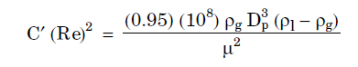
      - Drag Coefficient
The drag co-efficient was determined from the following chart, culled from GPSA Handbook, Chapter 7.

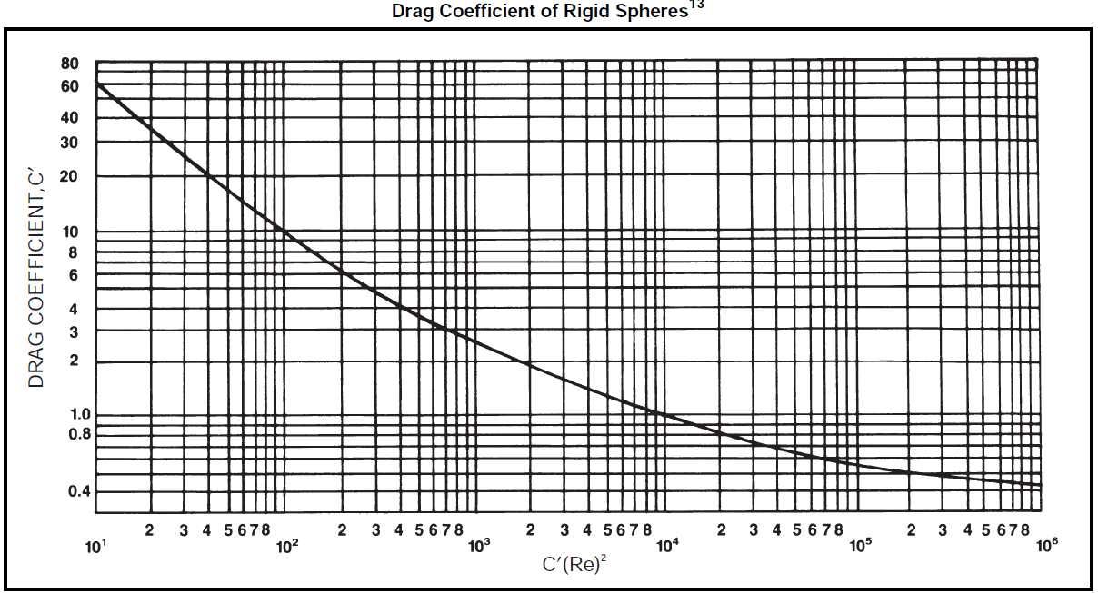
Figure 5.2: Reynold’s No. of Particle
$${Re}_{p}=\frac{{C'Re}_{p}^{2}}{C'}$$

      - Terminal Velocity
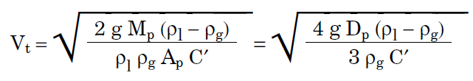
      - Proportion of Bottle for Liquid Storage and Gas Handling
It was assumed that 70% of the cross-sectional area of the primary bottle will be used for liquid storage while the remaining 30% will be used for gas handling.
      - Selected Primary Bottle Size
The nominal size of the primary bottles was selected based on acceptable industry practice of 1.5 x Pipeline size. The wall thickness is same as the pipeline wall thickness.
      - Cross Sectional Area Available for Gas Flow
(Proportion of Bottle for Gas Handling) x (Bottle Cross sectional Area)
      - Vertical Height of Bottle Occupied by Gas
Vertical height of bottle occupied by gas is found by iteration using the following formular.
$$Area occupied by Gas, A_{v}= {\left(\frac{D_{b}}{2}\right)}^{2}\cos^{-1}\left(\frac{\frac{D_{b}}{2}-d_{g}}{\left(\frac{D_{b}}{2}\right)}\right)-\left(\frac{D_{b}}{2}-d_{g}\right)\sqrt{2\left(\frac{D_{b}}{2}\right)d_{g}-d_{g}^{2}}$$
      - Settling Time of Liquid Droplets
$$Settling time, t=\frac{d_{g}}{V_{t}}$$
      - Limiting Gas Velocity inside Bottle
Industry best practice has it that settling of droplets can occur by gravitation in a primary bottle when flowing at low velocities, typically at less than 2 m/s, towards the gas riser, provided sufficient residence time is allowed for it to happen. For this design, 1 m/s was adopted.

      - Number of Primary Bottles
$$N=\frac{4(Q_{L}+Q_{G})}{πD_{b}^{2}V_{g}}$$The number of primary bottles, Nb is rounded up to the nearest power of 2.Error! Not a valid link.
$$L_{e}=\frac{4×t×Q_{g}}{πD_{b}^{2}}$$
      - Selected Number of Splitters
For efficient filling and maximum utilization of storage capacity of the slug catcher, the fluid flow was distributed equally between parallel bottles using splitters in the form of Tee-junctions with the flow impacting perpendicularly at the tee-junction before being divided into equal streams departing through the runs. The number of splitters is selected to limit the number of parallel fingers in each split to 4.

Summary of Separation Part Sizing CalculationError! Not a valid link.
Property | Symbol | Unit | Calculated Value
C'Re² |  |  | 8.98E+03
Drag Coefficient | C' |  | 1.12
Reynold's Number of Particle | Re_{p} |  | 8.02E+03
Terminal Velocity | V_{t} | ft/s | 0.400
Proportion of Bottle for Liquid Storage |  |  | 70%
Proportion of Bottle for Gas Handling |  |  | 30%
Selected Primary Bottle
Outside Diameter | OD | in | 48
Wall Thickness | WT | in | 0.94
Inside Diameter | D_{b} | ft | 3.843
Bottle Cross sectional Area | Ab | ft2 | 11.601
Cross Sectional Area Available for Gas Flow | A_{V} | ft2 | 3.480
Vertical Height of Bottle Occupied by Gas | dg | ft | 0.717
Settling Time | t | s | 1.793
Limiting Gas Velocity inside Bottle | Vg | ft/s | 1
Number of Primary Bottles Required | N |  | 4.255
Selected Number of Primary Bottle | Nb |  | 24
Length of Pipe Required for Separation | Le | ft | 6.97
Selected Number of Splitter | Ns |  | 6

Intermediate Section Length Sizing
The intermediate section is located between the gas-liquid separation section and the slug-receiving section. It was designed based on the prohibition of liquid entry to the gas riser.
Industry best practices allow for selection of slope of this section to be between 2.5% and 5%. For this design, 2.5% was selected.
      - Length of Intermediate Section
$$L_{s}=\left(\frac{D_{b}}{\tan{θ}}\right)$$
Where, θ is the angle of slope of section with riser.Error! Not a valid link.
Intermediate Section Part Sizing
Angle of Slope of Intermediate Section | θ |  | 2.50%
Horizontal Length of Intermediate Section | Ls | ft | 153.733333

      - Slug Receiving Section Length
      - Expected Slug Volume Calculation
Liquid hold-up volume was calculated from:
(Mean Liquid Hold Up over entire pipeline) x (Pipeline Area) x (Pipeline Length)
Expected Liquid Hold-up was calculated as the sum of liquid hold-up volumes in each pipeline segment (BBOU-ELEP and ELEP-AKAB Pipelines)
Expected slug volume was then calculated as 120% of Expected Liquid Hold-up to cater for liquid carryout during slug arrival.Error! Not a valid link.
 | 100 barg Pressure
Parameters | BBOU-ELEP Pipeline | ELEP-AKAB Pipeline | Units
Pipeline Outside Diameter | 610 | 914 | mm
 | 578.24 | 866.34
Pipeline Internal Diameter | 0.57824 | 0.86634 | m
Pipeline Area | 0.263 | 0.589476661 | m²
Mean Liquid Hold Up | 0.1644 | 0.261280054
Pipeline Length | 6662.74 | 35676.75 | m
Liquid holdup Volume | 287.5960 | 5494.879293 | m3
Expected Liquid Hold Up Volume |  | 5782.4753 | m3
Parameters | 2027 - 340MMSCFD |  | Units
 | Expected Slug Volume (20% margin) | 245047.427 | ft3

      - Bottle Slope in Slug Receiving Section
Industry best practice allows for selection of slope of this section to be between 1% and 1.5%. For this design, 1.2% was selected.
      - Partially Filled Volume of Slug Catcher
For the purpose of determining the maximum capacity of the slug catcher, the volume in the partly filled part of the bottle can be assumed to be:
$$V_{part}=\frac{π}{8}\frac{\left(D_{b}^{3}\right)}{\tan{α}}$$

      - Residence Time
The time over which liquid surges have to be coped with is determined by the nature and operating philosophy of the system. It is a prerogative of the client and/or designer. The residence time is selected as 10 mins for this design.
      - Buffer Volume
Flow rate of Liquid x Residence Time
      - Total Anticipated Holding Volume
V_{tot} = V_{slug} +V_{buffer} – Partially Filled Volume
      - Length of Slug Receiving Section
$$L_{t}=\frac{4.8×(V_{tot})}{πD_{b}^{2}N_{b}}$$
      - Summary of Slug Receiving Section Length Sizing
Slug Receiving Section Length Sizing
Property | Symbol | Unit | Calculated Value
Expected Slug Volume | V_{slug} | ft³ | 206441.489
Partially Filled Angle | α |  | 1.20%
Partially Filled Volume | V_{part} | ft³ | 1857.81642
Assumed Residence Time | t_{res} | s | 600
Buffer Volume | V_{buffer} | ft³ | 2556.85232
Total Holding Volume | V_{tot} | ft³ | 207140.525
Length of Slug Receiving Section | Lt | ft | 855.55057
Slug Catcher Total Length | L_{total} | ft | 1016.2541

Error! Not a valid link.Gas Riser Sizing
      - Load Factor Parameter
The separation capability of a riser is determined by the load factor. Shell DEP specifies that load factor must be less than 0.20 m/s (0.6 ft/s) so that droplets larger than 2 mm will settle out from the stream. For this design, load factor of 0.4 ft/s was considered.

      - Superficial Velocity of Gas
$$V_{SG}=ξ\sqrt{\frac{ρ_{L}-ρ_{g}}{ρ_{g}}}$$
      - Required Inside Diameter of Riser
$$D_{riser}=\sqrt{\frac{Q_{g}}{N_{rb}\left(\frac{π}{4}\right)N_{b}V_{SG}}}$$
      - Selected Riser Diameter
A pipe that has internal diameter greater than calculated and having minimum wall thickness to maintain mechanical integrity was selected.
      - Height of the Riser above Separation Bottle
The Shell DEP states that “the riser should have a minimum height to allow liquid entrained in the riser gas stream to settle. The riser height should be at least 5 times its diameter or 5 m, whichever is less”.
      - Summary of Gas Riser Sizing Calculation
Property | Symbol | Unit | Calculated Value
Load Factor Parameter | ξ |  | 0.4
Superficial Velocity of Gas | Vsg | ft/s | 1.16408803
Number of Riser Per Bottle | Nrb |  | 1
Required Inside Diameter of Riser | Driser | ft | 1.43361249
Selected Riser Diameter | Riser |  | NPS 36
Height of Riser | Hriser | ft | 7.16806243
Error! Not a valid link.

Slug Catcher Calculations Summary Results
Fluid Properties (Derived from HYSYS)
Property | Symbol | Unit | Calculated Value
Gas Mass Flow Rate | W_{g} | lb/hr | 727996.33
Condensate Mass Flow rate | W_{c} | lb/hr | 649974.04
Water Mass Flow rate | W_{w} | lb/hr | 1436.33
Density of Gas | ρ_{g} | lb/ft³ | 4.48
Density of Condensate | ρ_{c} | lb/ft³ | 42.43
Density of Water | ρ_{w} | lb/ft³ | 61.98
Acceleration Due to Gravity | g | ft/s² | 32.2
Particle Diameter | D_{p} | micron | 150
Viscosity of Gas | μ | cP | 1.47E-02
Fluid Properties (Calculated)
Property | Symbol | Unit | Calculated Value
Total Liquid Mass Flow Rate | W_{L} | lb/hr | 651410.37
Density of Liquid | ρ_{L} | lb/ft³ | 42.46
Volumetric Flow Rate of Gas | Q_{g} | ft³/s | 45.10
Volumetric Flow Rate of Liquid | W_{l} | ft³/s | 4.261
Separation Part Sizing
Property | Symbol | Unit | Calculated Value
C'Re² |  |  | 8.98E+03
Drag Coefficient | C' |  | 1.12
Reynold's Number of Particle | Re_{p} |  | 8.02E+03
Terminal Velocity | V_{t} | ft/s | 0.400
Proportion of Bottle for Liquid Storage |  |  | 70%
Proportion of Bottle for Gas Handling |  |  | 30%
Selected Primary Bottle
Outside Diameter | OD | in | 48
Wall Thickness | WT | in | 0.94
Inside Diameter | D_{b} | ft | 3.843
Bottle Cross sectional Area | Ab | ft2 | 11.601
Cross Sectional Area Available for Gas Flow | A_{V} | ft2 | 3.480
Vertical Height of Bottle Occupied by Gas | dg | ft | 0.717
Settling Time | t | s | 1.793
Limiting Gas Velocity inside Bottle | Vg | ft/s | 1
Number of Primary Bottles Required | N |  | 4.255
Selected Number of Primary Bottle | Nb |  | 24
Length of Pipe Required for Separation | Le | ft | 6.97
Selected Number of Splitter | Ns |  | 6
Intermediate Section Part Sizing
Angle of Slope of Intermediate Section | θ |  | 2.50%
Horizontal Length of Intermediate Section | Ls | ft | 153.733333
Slug Receiving Section Length Sizing
Property | Symbol | Unit | Calculated Value
Expected Slug Volume | V_{slug} | ft³ | 206441.489
Partially Filled Angle | α |  | 1.20%
Partially Filled Volume | V_{part} | ft³ | 1857.81642
Assumed Residence Time | t_{res} | s | 600
Buffer Volume | V_{buffer} | ft³ | 2556.85232
Total Holding Volume | V_{tot} | ft³ | 207140.525
Length of Slug Receiving Section | Lt | ft | 855.55057
Slug Catcher Total Length | L_{total} | ft | 1016.2541
Gas Riser Sizing
Property | Symbol | Unit | Calculated Value
Load Factor Parameter | ξ |  | 0.4
Superficial Velocity of Gas | Vsg | ft/s | 1.16408803
Number of Riser Per Bottle | Nrb |  | 1
Required Inside Diameter of Riser | Driser | ft | 1.43361249
Selected Riser Diameter | Riser |  | NPS 36
Height of Riser | Hriser | ft | 7.16806243

Slug Catcher Summary
S/N | Parameter | Value | Units
1 | Total Length of Slug Catcher | 1016.3 | ft
 | Length of Pipe Required for Separation | 7.0 | ft
 | Horizontal Length of Intermediate Section | 153.7 | ft
 | Length of Slug Receiving Section | 855.6 | ft
2 | Primary Bottle
 | Outside Diameter | 48.0 | in
 | Selected Number of Primary Bottle | 24.0
3 | Gas Riser
 | Selected Riser Diameter | NPS 36
 | Height of Riser | 7.2 | ft
4 | Total Capacity of Slug Catcher | 36893.3 | bbl
5 | Estimated Width of Slug Catcher | 138.0 | ft

The Slug Catcher Sketch
Plan & Sectional Views of the Slug Catcher is shown below

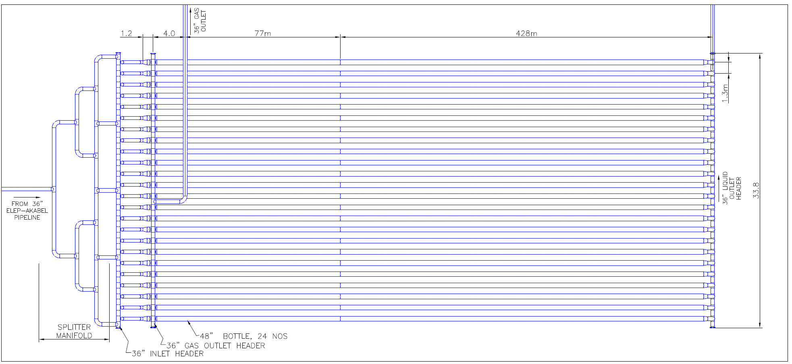

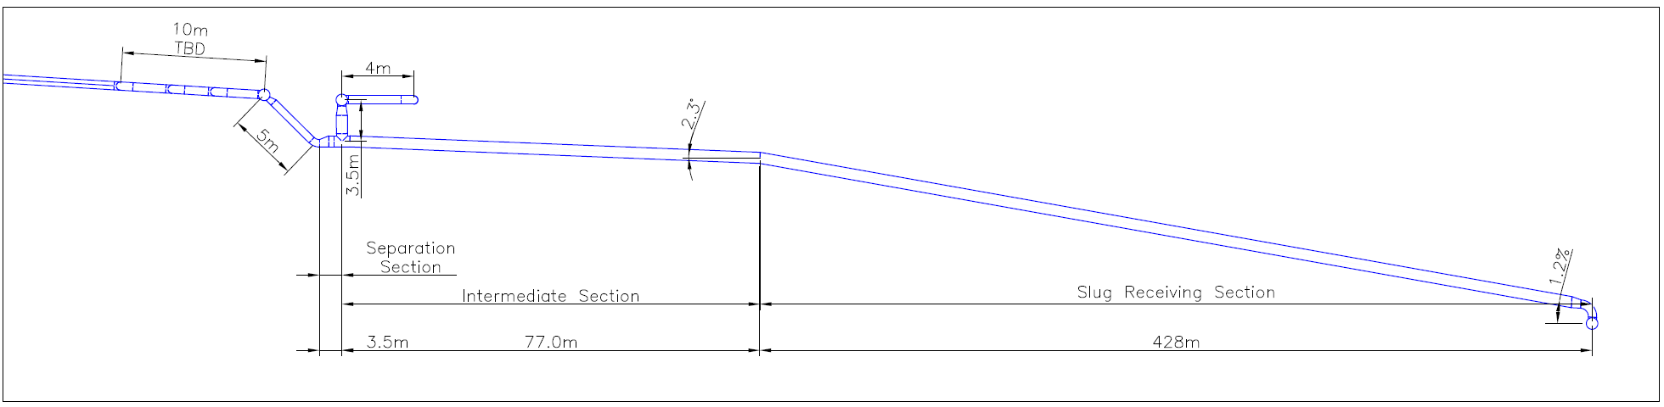

MECHANICAL DESIGN

GENERAL
The Slug catcher is an integral part of the pipeline system and thus shall meet the requirements of DEP 31.40.00.10-Gen. for category D fluid. The demarcation of the slug catcher with downstream facilities shall be indicated on the process engineering flow schemes.

MAXIMUM ALLOWABLE OPERATING PRESSURE
The MAOP of the slug catcher shall not be less than the MAOP of the feeding pipeline system if line packing is required for the operation of the pipeline system. If line packing is not required, then the MAOP of the slug catcher should still equal the MAOP of the feeding pipeline system as this will negate the requirement for separate overpressure protection.
Alternatively, if line packing is not required the MAOP of the slug catcher may be lower than for the feeding pipeline system if a significant net lifecycle cost benefit can be demonstrated from lowering the MAOP and installing dedicated overpressure protection for the slug catcher.

DESIGN FACTOR FOR HOOP STRESS
The design factor to limit the hoop stress arising from pressure containment shall be selected according to DEP 31.40.00.10-Gen.

OTHER STRESS
All loads shall be considered when determining combined stresses during pressure testing and operations. These loads will include:
- pressure;
- thermal expansion;
- passage of slugs or surges;
- foundation and support reaction;
- settlement;
- environmental loads.
Deformations due to the possible different settlements of the slug catcher and the connecting structures shall be accounted for. For buried slug catchers, possible deformations predicted at the transitions between exposed and buried parts, due to different settlements of the slug catcher and the connecting structures, shall also be accounted for.
The total longitudinal stress due to the internal pressure and weight of catcher including content shall not exceed 2/3 of SMYS. The equivalent stresses shall not exceed the limits specified in DEP 31.40.00.10-Gen.

SUPPORTS AND ANCHORS
ANSI/ASME B31.8, shall apply for the design of supports and anchors. The foundation of locally supported slug catchers shall be in accordance with DEP 34.19.20.31-Gen. The bottles of a buried slug catcher should be situated entirely below original ground level in areas with a natural slope similar to the downward slope necessary for the gravity fill of the bottles.
On a level plot, the bottles may be buried in a stable sand mound above the original ground level, with the liquid outlet header above the original ground level, or to reduce the height of the mound, in a shallow pit.

MATERIAL SELECTION

Linepipe
Linepipe used for bottle sections of the slug catcher shall be in accordance with DEP 31.40.20.37-Gen.

Fittings
Fittings shall be in accordance with DEP 31.40.21.30-Gen.

Flanges
Flanges shall be specified on the basis of ASME B16.5 and/or MSS SP-44.

Valves
Valves shall be in accordance with API Spec 6D.

Prevention of brittle fracture
The selection of slug catcher materials exposed to low temperatures shall be in accordance with DEP 30.10.02.31-Gen.
A reference minimum metal temperature shall be established under the most adverse combination of depressurization and climate. The lowest temperature occurring in the slug catcher during depressurization shall be determined, taking into account the heat content of the slug catcher wall and the heat influx from outside.
Under certain circumstances the lower design temperature can be taken to be 50 °C above the reference minimum metal temperature. A detailed evaluation of the limiting values of primary local membrane stresses, accounting for the time-dependent relation between temperature and pressure during depressurization, shall be performed to establish the applicability of the 50 °C relaxation.

WELDING
Welding shall be in accordance with DEP 61.40.20.30-Gen.

INTERNAL/EXTERNAL CORROSION PROTECTION
The potential for internal corrosion in the slug catcher shall be evaluated to determine the need for a corrosion allowance or other measures to mitigate internal corrosion.
Cathodic protection of a buried slug catcher shall be in accordance with DEP 30.10.73.31-Gen.
Anti-corrosion coating of both buried and non-buried slug catchers shall be in accordance with DEP 31.40.00.10-Gen.

OVERPRESSURE PROTECTION
Separate dedicated overpressure protection shall not be required if the MAOP of the slug catcher is not less than the MAOP of the feeding pipeline system.
If the MAOP of the slug catcher is less than the MAOP of the feeding pipeline system then it shall be safeguarded against overpressure by full flow relief protection in accordance with DEP 31.40.10.14-Gen.

MAINTENANCE
Ancillary equipment, such as PSVs, blowdown valves and liquid level shut down valves, which may require replacement shall be provided with the necessary isolation to permit maintenance without the shutdown and/or decommissioning of the slug catcher and other relevant facilities.
Both ends of headers shall be provided with end flanges for inspection access and for providing ventilation during the inspection. Both ends of liquid headers shall be provided with end flanges to facilitate the removal of sludge.
Requirements for the condition monitoring of buried slug catchers shall be established during the design stage and be designed to minimise the requirement for future excavation.

